Dear «First_Name» «Last_Name»

This is to inform you that Your balance is due for the month of against account number. You are requested to submit the payment AS SOON AS POSSIBLE

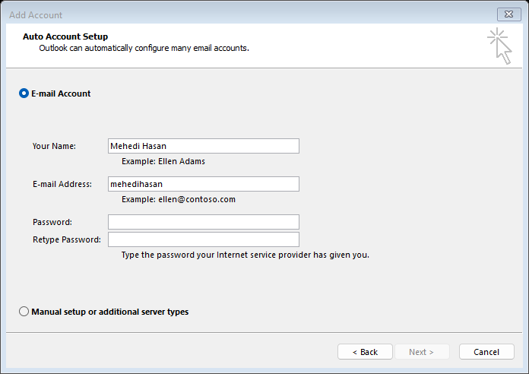Payment Details

NIYD Training & Solutions

Bank Name: Bangla Bank

Bank Account Number:

Routing Code:

Email: «Email»

Regards,

Team NIYD

«Phone»

«Email»